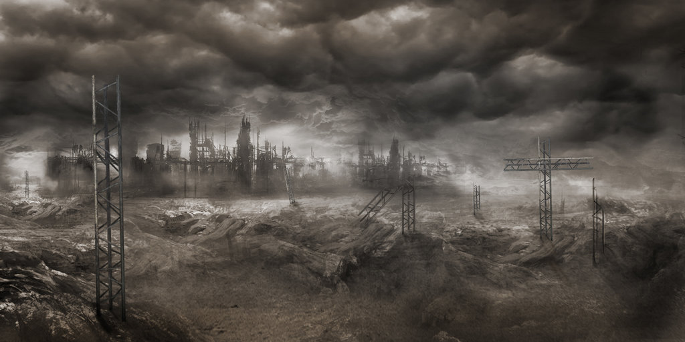Shipwrecked

By Small Room Productions

Drake Addis

Ben Clarke

Chris Crain

Ryan Liu

Greg Sop

Adam Sturgeon

Songnan Wu



Table of Contents

Introduction 3

Game Concept 3

Gameplay 3

Single Player 3

Multi-Player 4

Key Game Components 5

Basic Controls 6

Characters 6

Character Selection 6

Weapons 7

Special Abilities 8

Sergeant Peter Fremin(Sarge) 8

Doctor Tyler Yusko (Doc) 9

Mechanic Mike Raider(Grease) 9

Captain Hugo Stiglitz(Captain) 9

Upgrade System 9

Enemies 10

Enemy Waves: 11

Technical Features 12

Multiplayer 12

Photon Unity Networking (PUN) 12

Lobby System 12

Artificial Intelligence 12

A* Pathfinding Project (APP) 12

Assets 14

Code References 15

Highlights 16

Credits 17

# 

# Introduction

## Game Concept

**Story:**

Two hundred years after migrating into space, mankind is in turmoil.

Humanity has colonized the Solar System – Mars, the Moon, the Asteroid Belt and beyond – but the stars are still out of our reach.

The mineral-rich outer planets resent their dependence on Earth and Mars, and the political and military clout they wield over the Belt and beyond.

A colony on one of the moons of Jupiter (Athara) has gone radio silent. The colony was a joint venture by Earth and Mars meant to improve relations between the two planets and extract precious Uranium for use in the fusion reactors that power all space travel.

With the recent assassination of the Prime Minister of Earth (Michael Chelenkof) and loss of contact with the colony, tensions between Earth and Mars have never been higher.

An investigation team made up of members from both Earth and Mars has been dispatched to investigate why the colony stopped responding to messages and determine who is at fault.

During the descent down to the moon’s surface, there is a critical failure leading to an uncontrolled descent. The captain is left with the decision to perform an emergency crash landing on the surface.

The surviving members of the crew discover a hostile environment with a constant swarm of enemies assaulting them and their ship. Their only hope for survival is to collect the necessary parts required to repair their ship and escape from Athara.

## Gameplay

### Single Player

Your ship has crash landed, and you must survive and escape the planet. You have a gun to fend off the enemy and the ability to repair your spaceship with parts that can be found around the map. You are required to find Reactor Fuel, Hydraulic Lines, High Pressure Hoses, Clamps, and a Navigation Screen. These parts have been spread around the map in your descent to the planet. You must fight your way to these supplies while keeping your ship from being destroyed. Enemies have been awoken by your crash. Enemies spawn from hives that are located throughout the map.. Enemies differ in size, speed, and strength. The player gains experience for each enemy that they kill. The experience the player gains differs for each type of opponent. Small Critters give the player one experience point when killed.

The goal of the game is to collect the parts required to repair your ship without you or your ship being destroyed.

### Multi-Player

Game will consist of four players, working together, to collect parts to repair their ship to escape the moon. Players have to work together to collect all the needed parts from around the map while defending their ship. Players will each have different specialties and skills in order to help them on this mission.

# Key Game Components

## Map

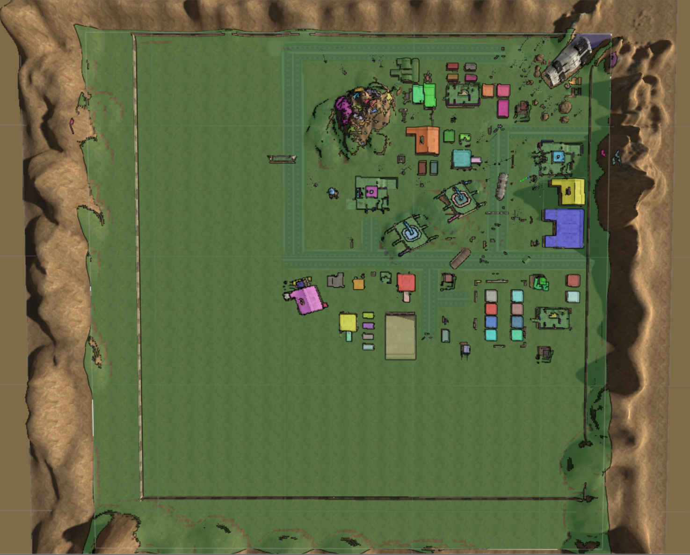

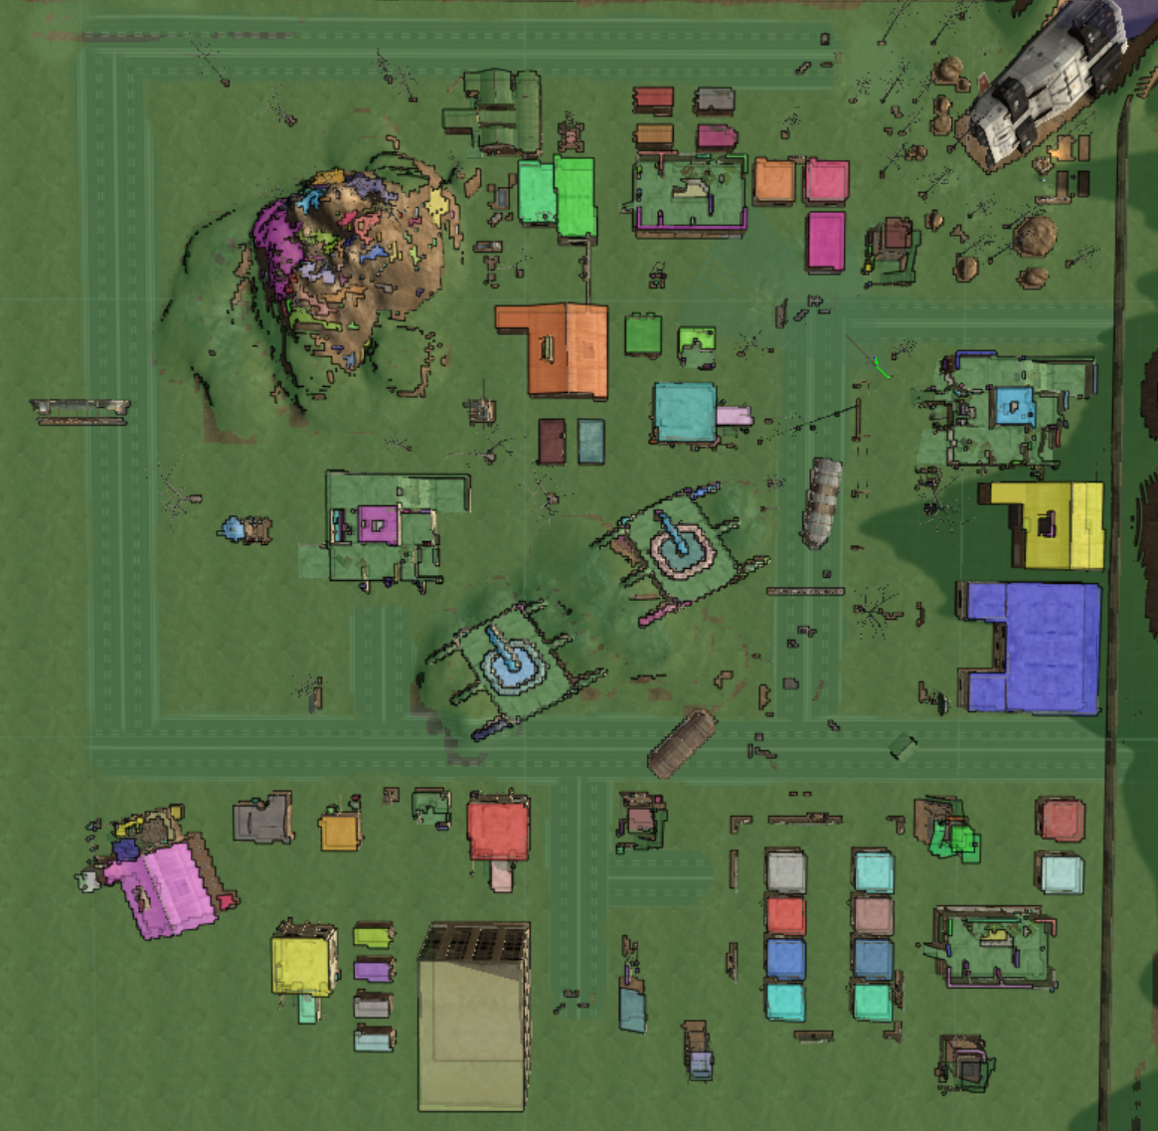

## 

## Screen Clipping

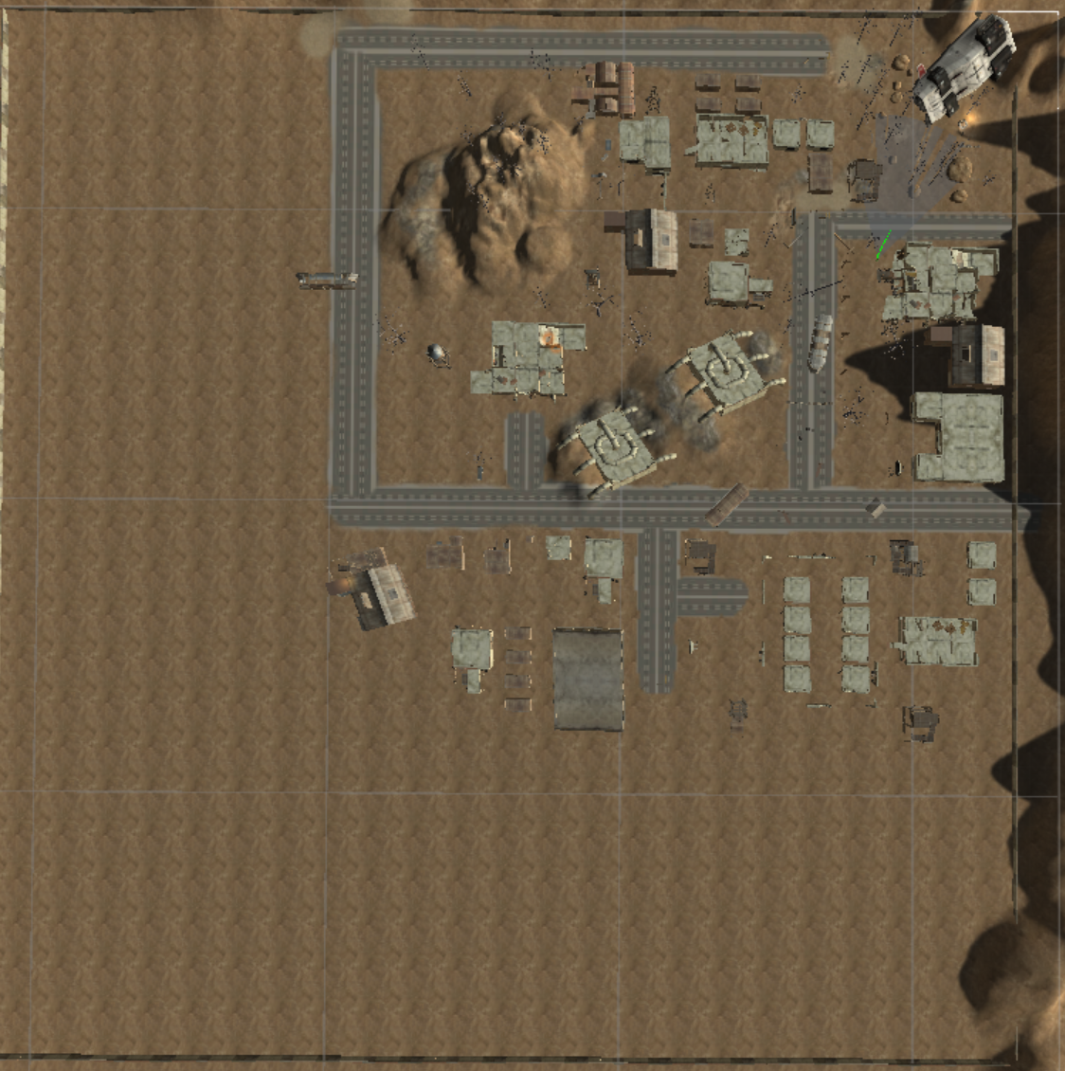

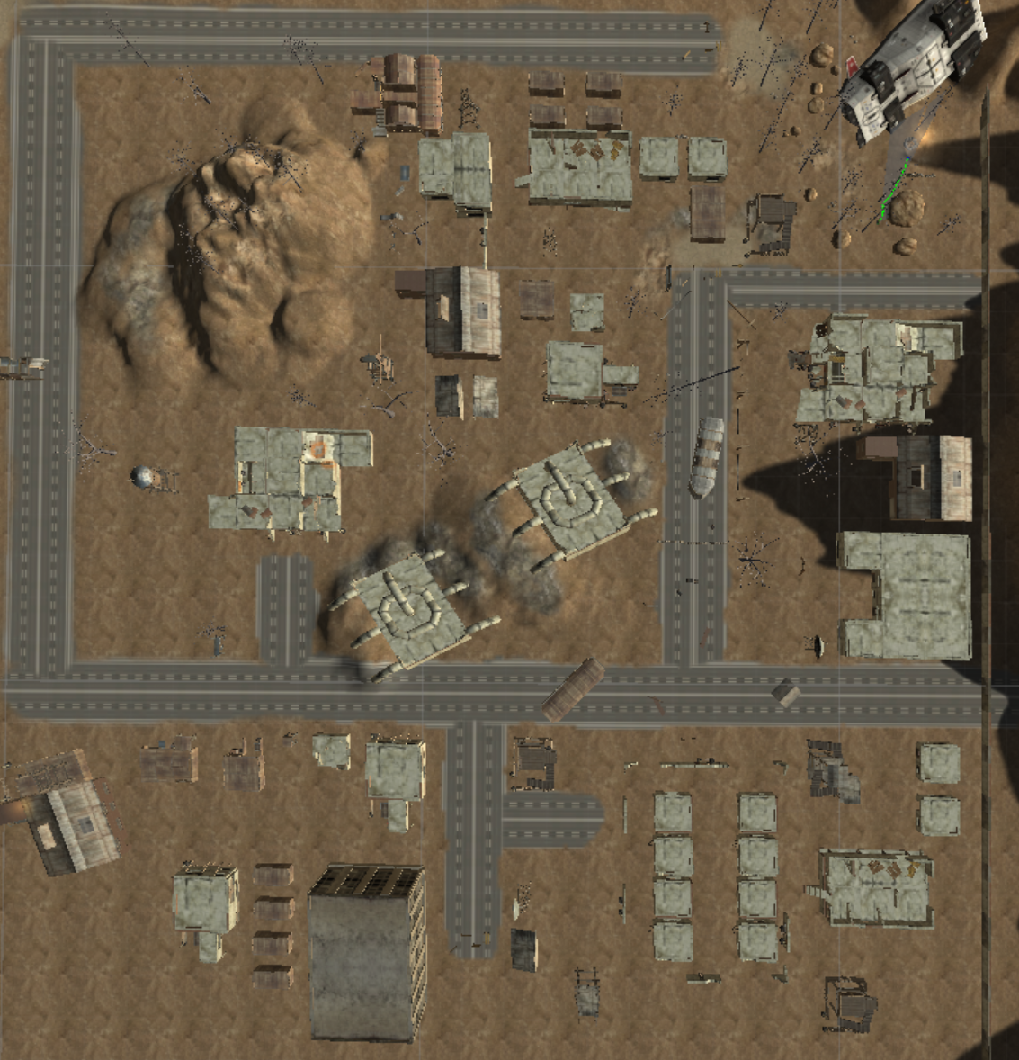

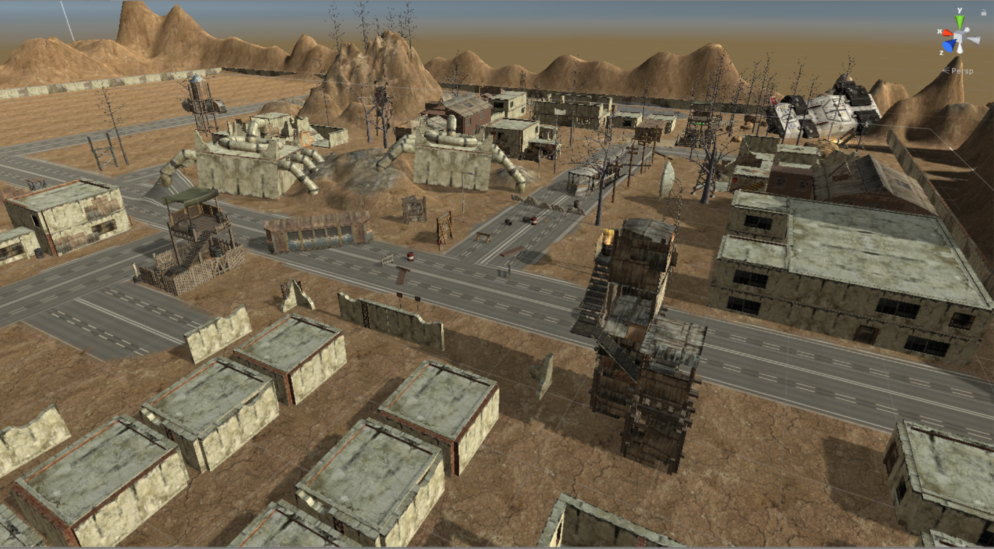

## Basic Controls

WASD, Up/Down/Left/Right – Move

Shift+WASD – Sprint

Left Click – Shoot

Right Clock – Aim Mode

Q – Special Ability

E – Special Skill

R – Reload

C – Roll

Space – Jump

F – Pick up

## Characters

### Character Selection

Each player gets to choose from four different characters.

Sergeant Peter Fremin (Sarge)

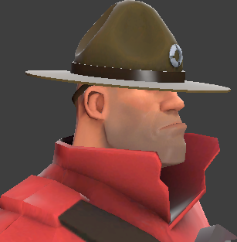 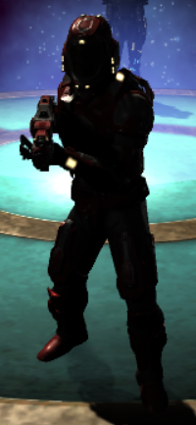

Equipped with advanced weaponry and armor that can be upgraded with experience. Has minimal ability to heal without the assistance of Doc.

Doctor Tyler Yusko (Doc)

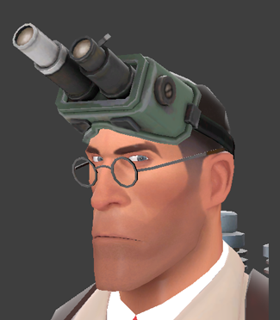 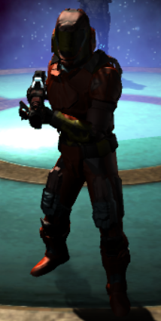

Advanced medical knowledge allows him to heal other players at an advanced rate. Decreased armor and weaponry capabilities. With increased research into enemy, can allow for increased effectiveness in battle for allies.

Mechanic Mike Raider (Grease)

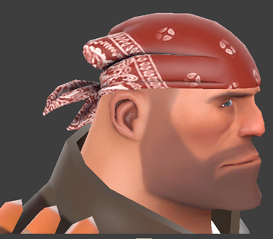 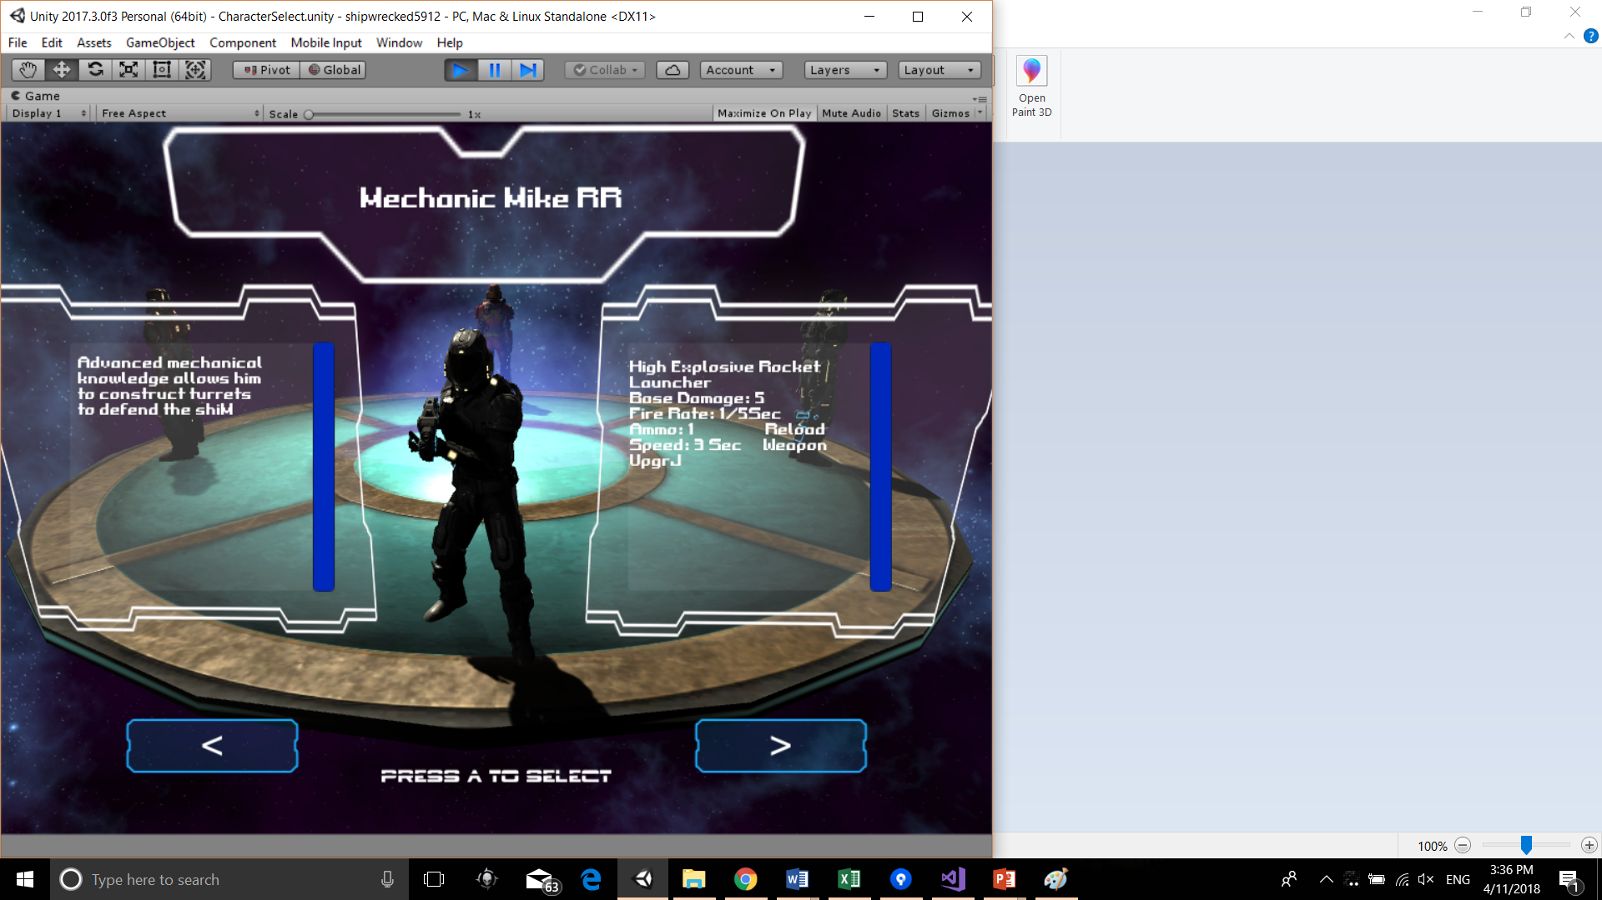

Advanced mechanical knowledge allows him to construct turrets to defend the shipwreck. Ability to acquire and employ the use of explosives to deal considerable damage to hives and enemy units.

Captain Hugo Stiglitz (Captain)

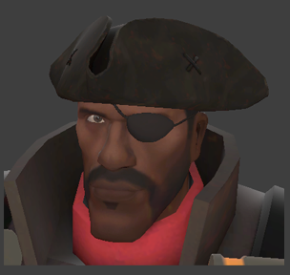 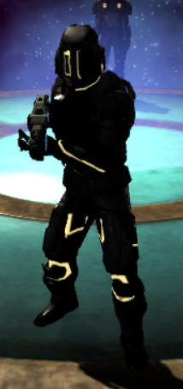

Advanced combat abilities that leaves enemies stunned or deceased. Has improved accuracy and power.

## Weapons

**Sergeant Peter Fremin (Sarge)**

Martian Assault Rifle (Base Damage: 1 | Fire Rate: 5/Sec | Ammo: 15 | Reload Speed: 4 Sec)

Damage Upgrade: +1 Damage, +2 Damage, +3 Damage, +4 Damage

Final Weapon Upgrade: 1 Shot Kill (Ammo = 1, Damage = 100, Reload = 6 Sec)

**Doctor Tyler Yusko (Doc)**

Laser Pistol (Base Damage: 2 | Fire Rate: 1/Sec | Ammo: 12 | Reload Speed: 2 Sec)

Damage Upgrade: +1 Damage, +2 Damage, +3 Damage, +4 Damage

**Mechanic Mike Raider (Grease)**

High Explosive Missile Launcher (Base Damage: 5| Fire Rate: 1/2 Sec| Ammo: 2 | Reload Speed: 3 Sec)

Damage Upgrade: +1 Damage, +2 Damage, +3 Damage, +4 Damage

**Captain Hugo Stiglitz (Captain)**

Martian Assault Rifle (Base Damage: 1 | Fire Rate: 5/Sec | Ammo: 15 | Reload Speed: 4 Sec)

Damage Upgrade: +1 Damage, +2 Damage, +3 Damage, +4 Damage

## Special Abilities

Q Key: Allows use of first skill

E Key: Allows use of second skill

### Sergeant Peter Fremin (Sarge)

Skill: Apply Field Dressing (+20HP)

### Doctor Tyler Yusko (Doc)

First Skill: Heal Others (+w1HP/Sec for Ally)

Second Skill: Research (All Players +3 Attack & +3 Defense)

### Mechanic Mike Raider (Grease)

Q to use skill, then select location, then E to confirm

Skill: Construct Turret (Base Damage: 2 | Fire Rate: 1/3 Sec | Ammo: Unlimited | Reload Speed: 0 Sec | Cooldown: 20 Sec)

Level 5: Construct Advanced Turrets (Base Damage: 3 | Fire Rate: 1/3 Sec | Ammo: Unlimited | Reload Speed: 0 Sec | Cooldown: 20 Sec)

Level 10: Construct Minigun Turrets (Base Damage: 5 | Fire Rate: 1/3 Sec | Ammo: Unlimited | Reload Speed: 0 Sec | Cooldown: 20 Sec)

### Captain Hugo Stiglitz (Captain)

First Skill: Rampage (Attack +1, Defense +1, Accuracy increased)

Second Skill: Stun Enemy (Enemy freezes for 5 seconds)

## Upgrade System

Player Attributes:

Players Start with 100 Health

Player Levels:

Level 1: Default skills and Weapon attributes.

Level 2: 20 exp

Level 3: 40 exp

Level 4: 80 Exp

Level 5: 100 Exp

Level 6: 150 Exp

Level 7: 200 Exp

Level 8: 250 Exp

Level 9: 300 Exp

Level 10: 500 Exp

## Enemies

Crab Alien: Speed = 5, Health = 5 HP, Attack = 10 Damage

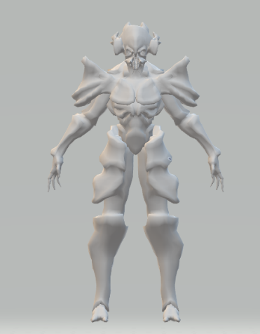

Spider Brains: Speed = 8, Health = 10 HP, Attack = 5 Damage

Provides +5 Attack and Health to Crab Aliens within area

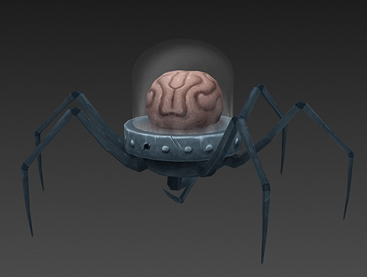

Hive: Health = Infinite, Attack = 0, Speed = 0

Where enemies spawn

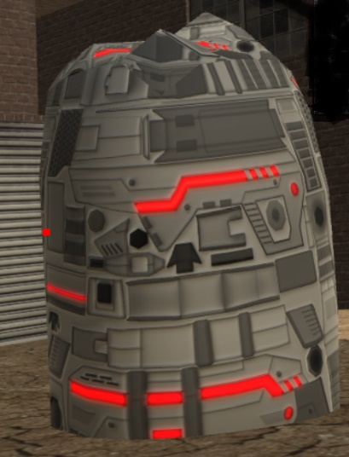

### Enemy Waves:

Enemy units spawn from one of the eight hives located around the map. Each hive can spawn multiple types of units and can increase the rate of spawn based upon the level.

Enemy Spawn Rate: Enemies spawn from hives at rate determined by Spawn Manager.

The enemy spawn rate and type is controlled by the number of ship parts have been collected, the number of enemy spawn points (hives) have been destroyed, and time. Each time a player collects a part to repair their ship this will progress them to the next level.

# Technical Features

## Multiplayer

### Photon Unity Networking (PUN)

Using Photon, a Unity asset that allows for network connectivity with ease, networking capabilities were developed with a lobby system in mind. Due to a large community backing and a well-documented API, Photon Unity Networking (or PUN) was favored over Unity’s networking. Since the game in mind is a co-op multiplayer game with a vast amount of controls, it seemed natural to include online multiplayer in a lobby system for friends to enjoy the game together. Photon allows for 20 concurrent players at a time under the free plan, which will be more than enough for our purposes.

### Technical Hurdles

In the initial implementation of networked multiplayer, the gameplay was extremely laggy for each other, with a ping jumping from 15ms as a solo player to 100+ ms when multiple players arrive in a match. This issue arose due to an issue when interpolating player movement, as opposed to extrapolating it. Interpolation is necessary when you know what exact values you need in the next frame. At the same time, it is only necessary when exact positions are required. Since this is a game focused on the shooting/co-op aspect, pinpoint accuracy in positions is not required. Instead, extrapolating the positions allows for smoother gameplay with greatly reduced lag (30 ms networked).

### Dead Reckoning

Photon uses a “Dead Reckoning” method for extrapolating networked players. When an entity is created locally, it sends out an entity state protocol data unit (PDU) across the network. This contains information like the position, rotation, and the dead reckoning algorithm to be used by that entity over the network. This allows for less network traffic, and the PDU is resent at a minimum of once every 5 seconds.

### Lobby System

In the multiplayer mode, players may join a game using an alias created upon starting up multiplayer. This alias does not have to be unique, nor is an account required. The alias is saved locally between sessions, so a player’s previous nickname is saved so that the player does not have to enter their nickname every session.

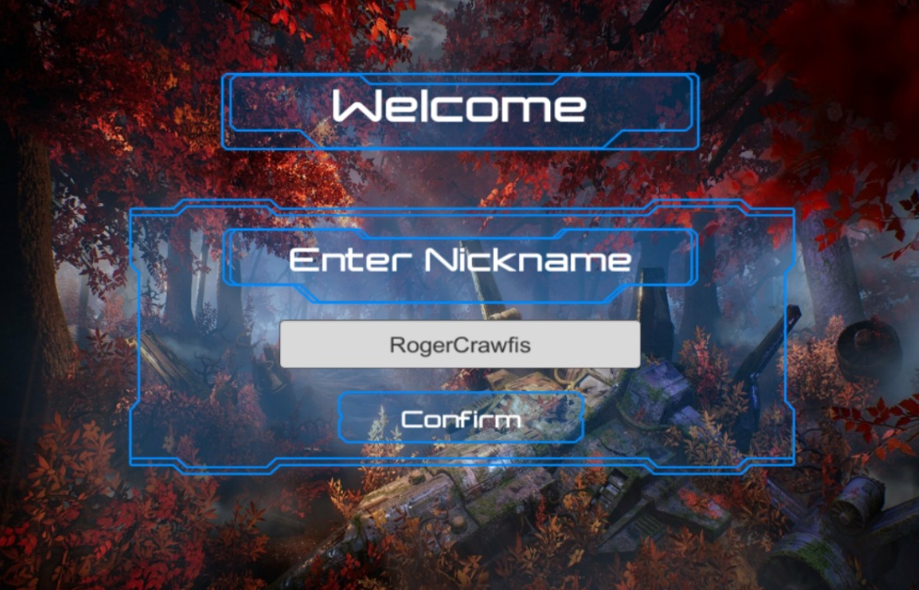

Upon creating the nickname, a lobby menu appears. This menu allows the player to view all available lobbies to join, or even create their own lobby to play with friends.

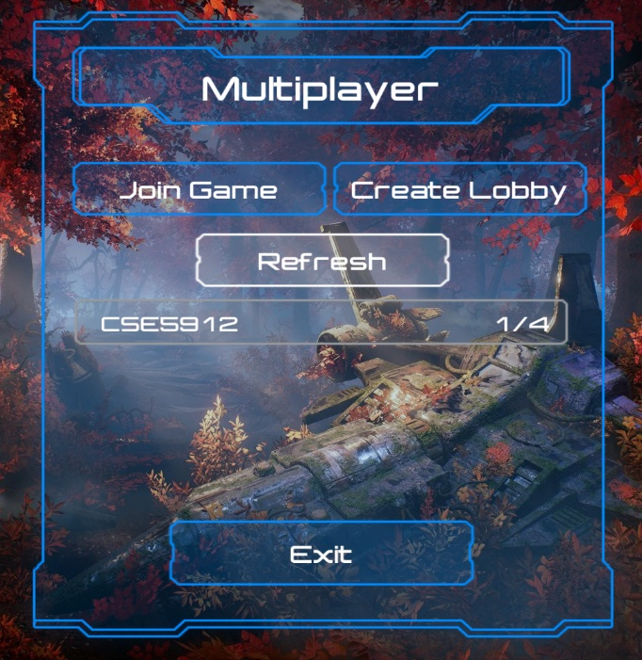

Creating A Game

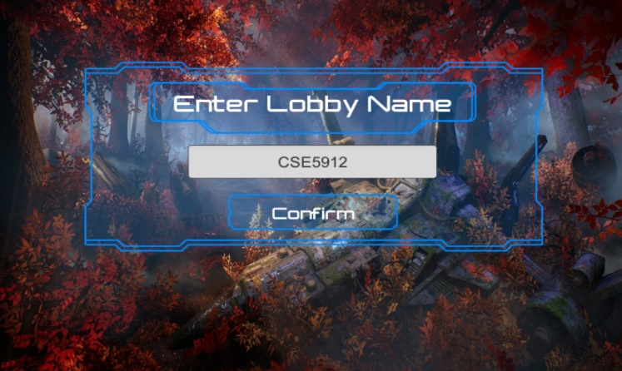

Starting A Game

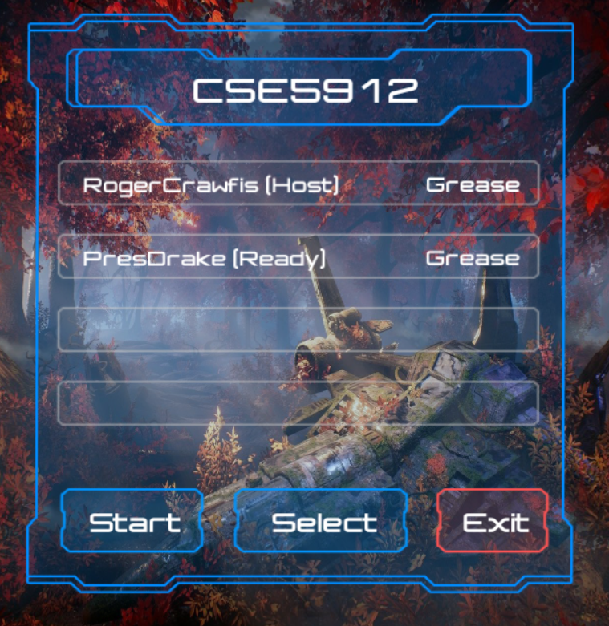

## Artificial Intelligence

### A* Pathfinding Project (APP)

Using APP, a Unity asset that allows for efficient and easy to use A* pathfinding, pathfinding was setup with more advanced ideas in mind. Due to an active community and developers, a moderately well-documented API, as well as the benefits over Unity’s navmesh, A* Pathfinding Project (or APP) was chosen. Since the game in mind has enemies pathfinding to the players’ base, the functionality of a waypoint system was necessary; however, the monsters also need to be able to attack the players when they are within a certain distance. This requires being able to maneuver around objects to get to the player. Since APP includes a navmesh graph, a grid graph, and a point graph representation for the A* algorithm to traverse, it includes the necessary functionality required for both of the desired goals: object avoidance when attacking the player and waypoint traversal when attacking the base.

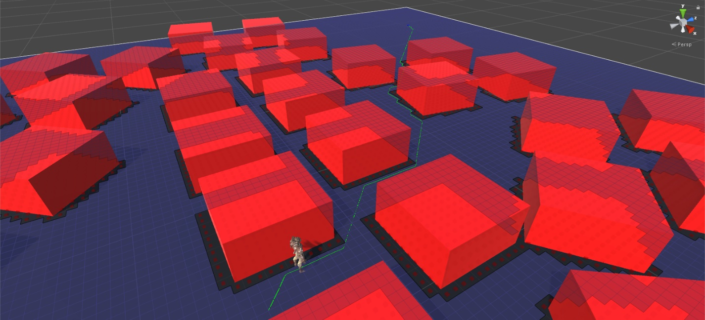

### Field of Vision (FOV)

All of the AI, from the different monsters to the turrets, have a field of view (henceforth FOV). The FOV is defined by an angle between (inclusive) 0 and 360 degrees. This is to allow each different type of monster, or the turrets, to have their own defined FOV. The FOV implementation allows for an offset position and an offset angle in case the designer wants to shift the FOV to a different location on the AI as well as to shift its angle from the object’s forward direction. One of the reasons to offset the starting position is that the designer may want to place the FOV at the “eyes” of the character, however, the center position of the object may not be located at the “eyes”. One reason to offset the angle is because the forward angle of the object may not be the same as the desired or actual forward facing angle, so an offset can correct this.

Some problems associated with implementing the FOV were that the FOV was not always placed at a desired location or facing the correct way, so offsets for the position and angle needed to be implemented. Another problem with the FOV was that the FOV would only target the center of its targets rather than the extents, so it was possible for up to half of a target to be visible before the FOV would detect the target. This lead to some humorous moments where the player could poke up to half their body around a corner and within the AI’s FOV, however, the AI could not see the player. This was later updated to allow the FOV to see the extents of the target rather than just the center position.



## Spawning

### Monsters

A simple, yet modular implementation for spawning was designed for spawning multiple monsters at various points through the map. A spawn manager is added to the scene where each of the spawn points are placed within the spawn manager. The spawn manager holds the crux of the logic while the spawn points only determine where the monsters spawn. The spawn manager takes into account a delay between spawn sessions as well as the delay between each of the spawn points (at a rate of 1 / SpawnRate seconds). It also keeps track of the maximum number of monsters that can be spawned and what types of monsters can be spawned at its spawn points. The spawn odds of each monster determines the probability of it spawning, where the probability is SpawnOdds / TotalOdds.

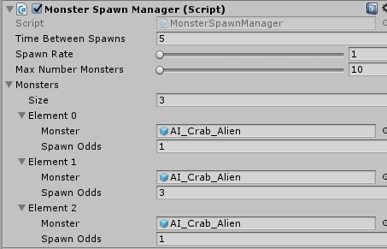

# Assets

<https://assetstore.unity.com/packages/vfx/particles/sci-fi-arsenal-60519>

<https://assetstore.unity.com/packages/2d/gui/complete-sci-fi-gui-psd-files-76123>

<https://assetstore.unity.com/packages/2d/gui/icons/sci-fi-skill-icon-pack-52852>

<https://assetstore.unity.com/packages/3d/environments/industrial/the-wasteland-48802>

<https://assetstore.unity.com/packages/3d/characters/creatures/crab-alien-67506>